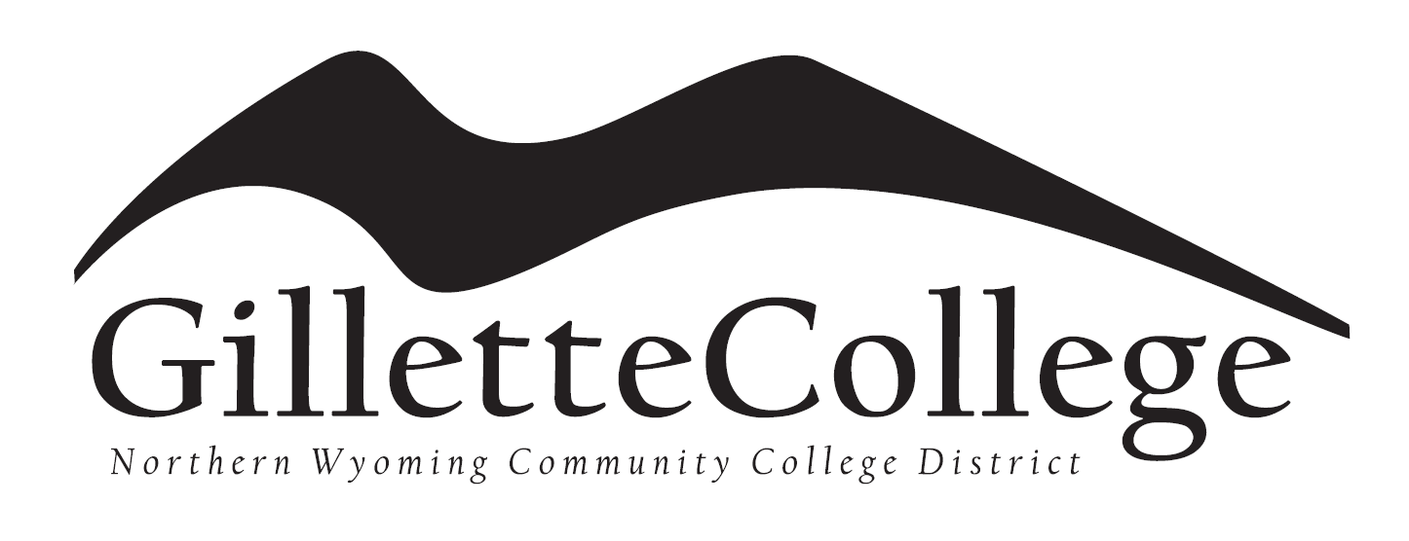
Concurrent Enrollment Application
Instructions: Complete both sides of application by providing answers to all questions. Must print legibly.
Questions, please call 307-681-6000

Personal Information:
- Name: _______________________________________________________________________
First Middle Last

- Gender: (circle one) Male Female

- Are you a US Citizen: (Yes or No) _________

- If you are not a US Citizen, what is your country of residence:

- Birthdate: Month Day Year

- Social Security Number: _______________________________________

- Mailing Address: __________________________________________________________________
Number & Street or PO Box City State Zip Code

- Phone Number: (Home) ________________________ (Cell) ____________________________

- E-mail Address: ______________________________________

Academic Information:
- Anticipated Entry Term: (Semester starting classes Fall 2020 or Spring 2020):

- High School Name: __________________________________

- Graduation Year (2021, 2022, etc.)
Demographics:
- Ethnic Status: (place an x next to one) Hispanic/Latino Non-Hispanic/Latino

- Race: (place an x next to one) American Indian/Alaska Native Asian Black or African American Native Hawaiian or other Pacific Islander White Choose not to answer

Certification:
PLEASE NOTE: Any applicant who gains admission on the basis of incomplete or fraudulent credentials or misrepresentation in the written application for admission, shall have admission and registration cancelled without refund of any fees, the total credits rescinded which have been earned following admission and future registration within the district prohibited.
- I certify the information provided on the application is accurate. Answer (yes or no):

- I agree to abide by the rules and regulations established by the Northern Wyoming Community College District. Answer (yes or no):

Your signature is your confirmation that the application you have filled out is your own work and the information is factually true.

Student Signature: Date:

Northern Wyoming Community College District prohibits discrimination in employment, educational programs and activities on the basis of race, national origin, color, creed, religion, sex, pregnancy, age, disability, veteran status, sexual orientation, gender identity, or any other class protected under state and federal law. The District also affirms its commitment to providing equal opportunities and equal access to its facilities. Inquiries concerning Title VI, Title VII, Title IX, Section 504, and the Americans with Disabilities Act may be referred to the Assistant Vice President for Human Resources, Jennifer McArthur, NWCCD’s Title IX and Section 504 Coordinator, Sheridan College, Griffith Memorial Building, Room 141D, 1 Whitney Way, Sheridan, WY 82801; 307-675-0505. Inquiries also may be made to the Office for Civil Rights, U.S. Department of Education, Federal Building, Suite 310, 1244 Speer Boulevard, Denver, CO 80204-3582; 303-844-3417; or TDD 303-844-3417.

